JOIN THE MIDDLE SCHOOL TRACK TEAM

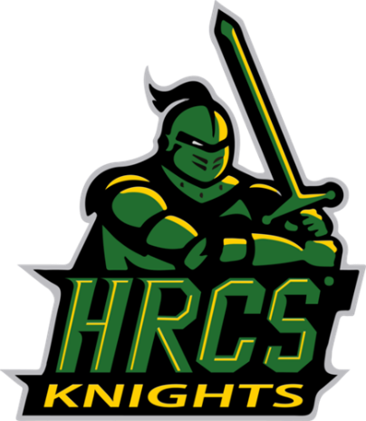

General Info
- Who? All 6th, 7th & 8th grade BOYS and GIRLS

- What? Track

- When? Practices Wednesdays Where? HRCS School Field
October 4th 3:00-4:30 pm (Practice and Informational)
November 1nd 3:00-4:30 pm
November 15th 3:00-4:30 pm
November 29th 3:00-4:30 pm
Meets Saturdays Where? Bishop Moore Catholic High School
November 4th Time TBD
November 18th Time TBD
December 2nd Time TBD

- Why? Get Stronger, Improve Overall Sports Performance, Make New Friends, Have Fun!

- How? Interested parents and athletes please, Sign up for more information




Name | Grade | Parents | Parents Email

